**Lab Exercise 6.1**

**Managing Jenkins Freestyle Jobs**

**Objective:** To manage Jenkins job by creating, renaming, and deleting freestyle job, facilitating streamlined job configuration and maintenance within the Jenkins environment

**Tools required:** Jenkins

**Prerequisites:** None

Steps to be followed:

1. Create a new Freestyle Job
2. Rename and delete the FreeStyle Job

**Step 1: Create a new Freestyle Job**

1. Open the browser, go to the Jenkins Dashboard by typing **localhost:8080** in your browser, provide the credentials, and click the **Sign in** button

|  |
| --- |
| **Note:** The credentials for accessing Jenkins in the lab are Username: **admin** and Password: **admin**. |

**Output:**

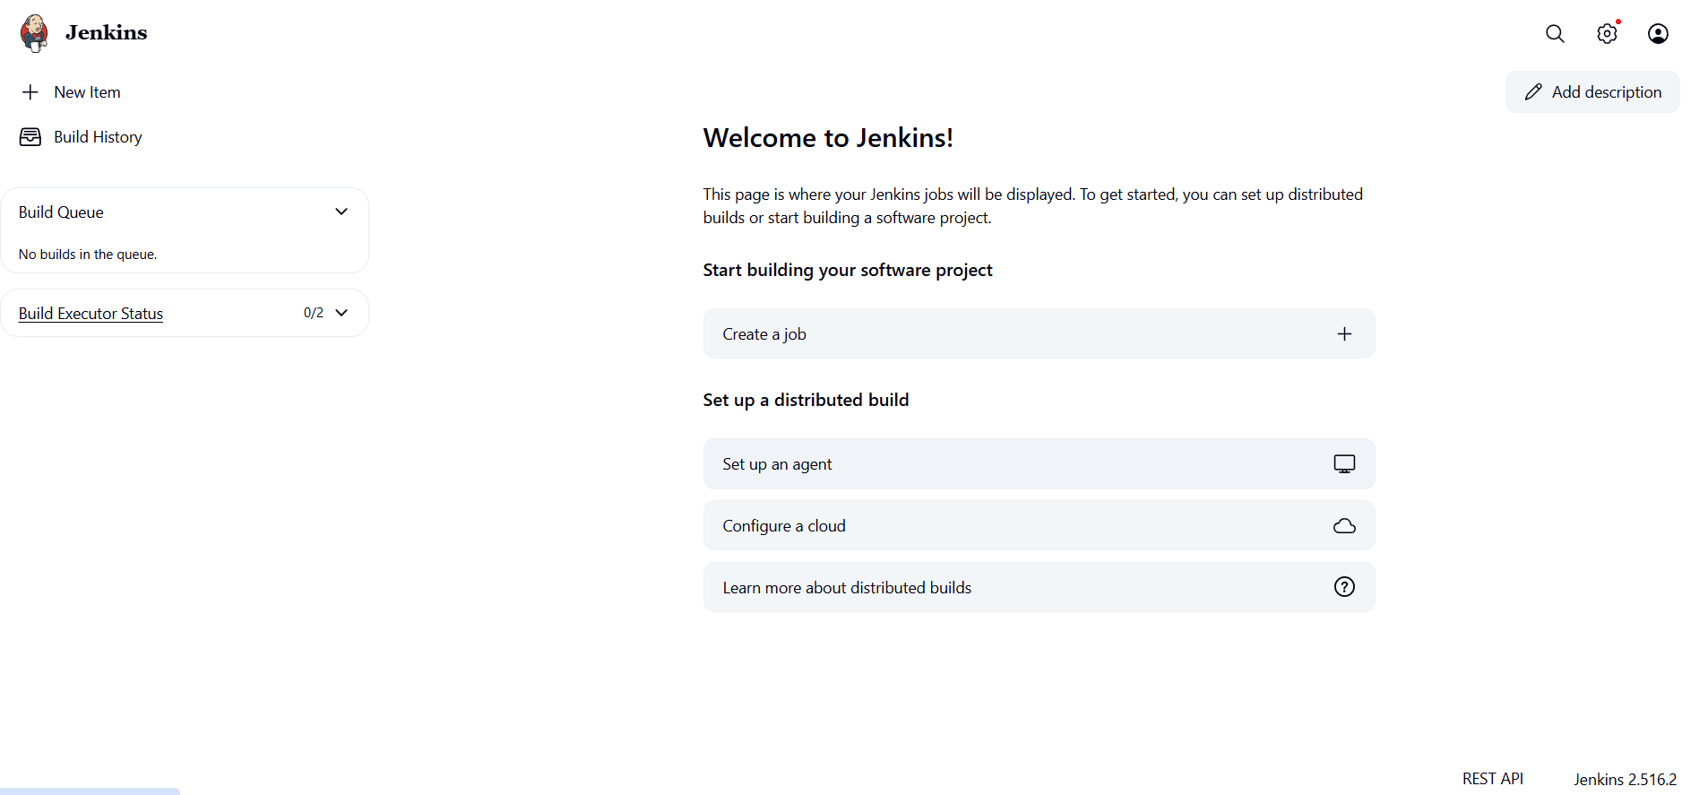

1. Click on **New Item** in the Jenkins **Dashboard**

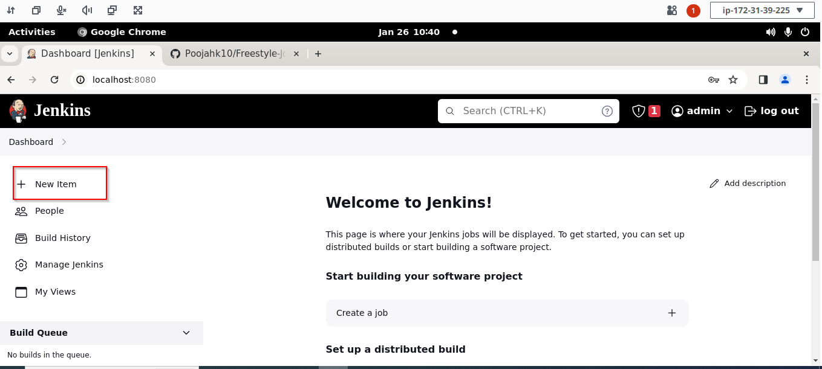

1. Enter a name for your project, select **Freestyle project** as the build job type, and click   
   on **OK**

1. Click on **Save**

Output:

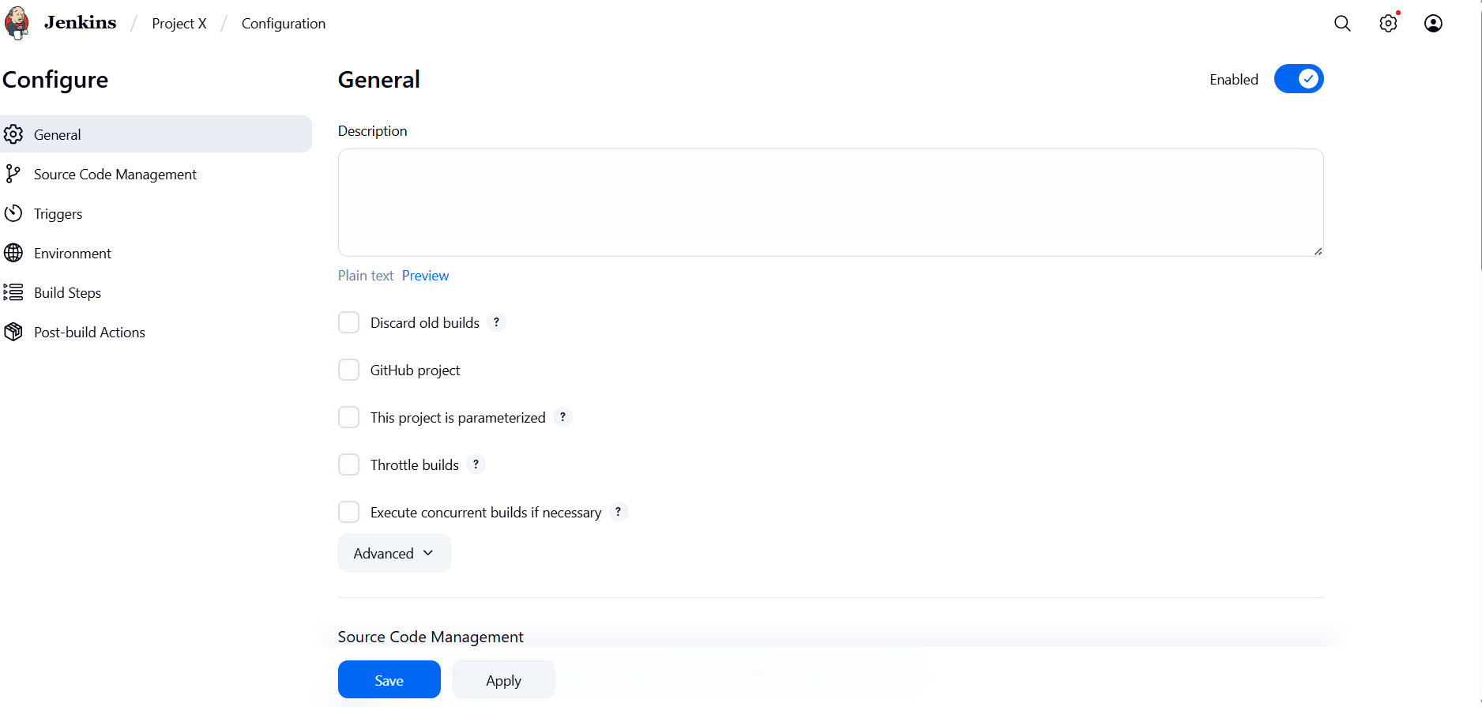

**Step 2: Rename and delete the Freestyle Job**

1. Click on the name of the project that you have created as shown in the screenshot below:

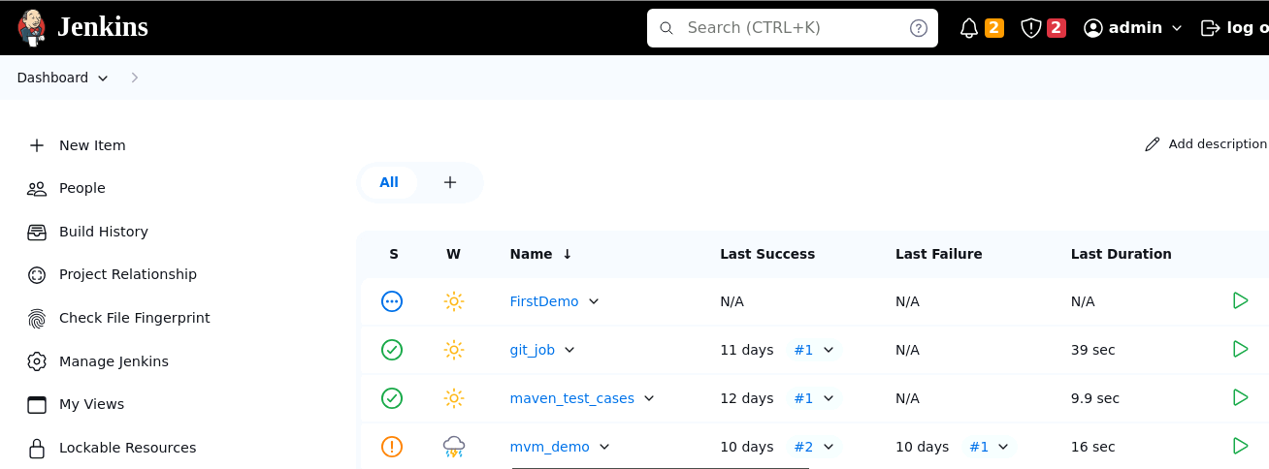

1. Click onthe **Rename** buttonto rename the project

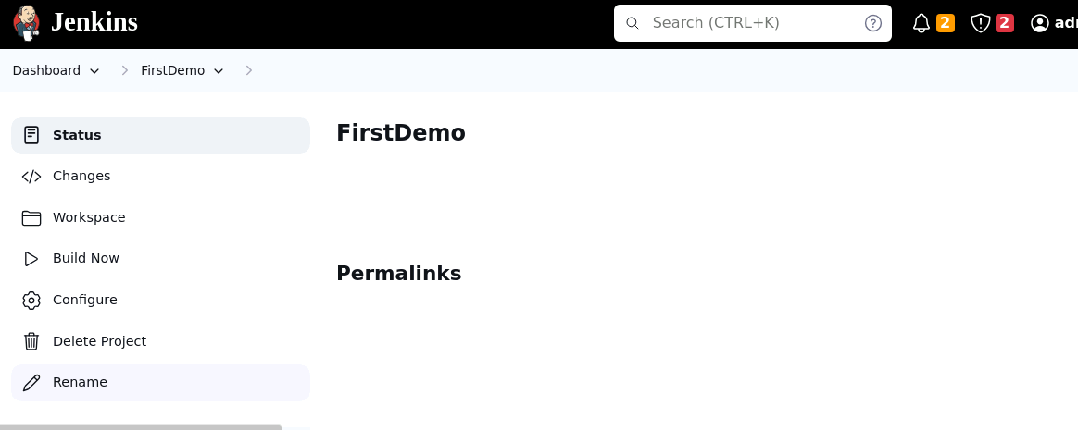

1. Enter a desired name to the project and click on **Rename**

**Output:**

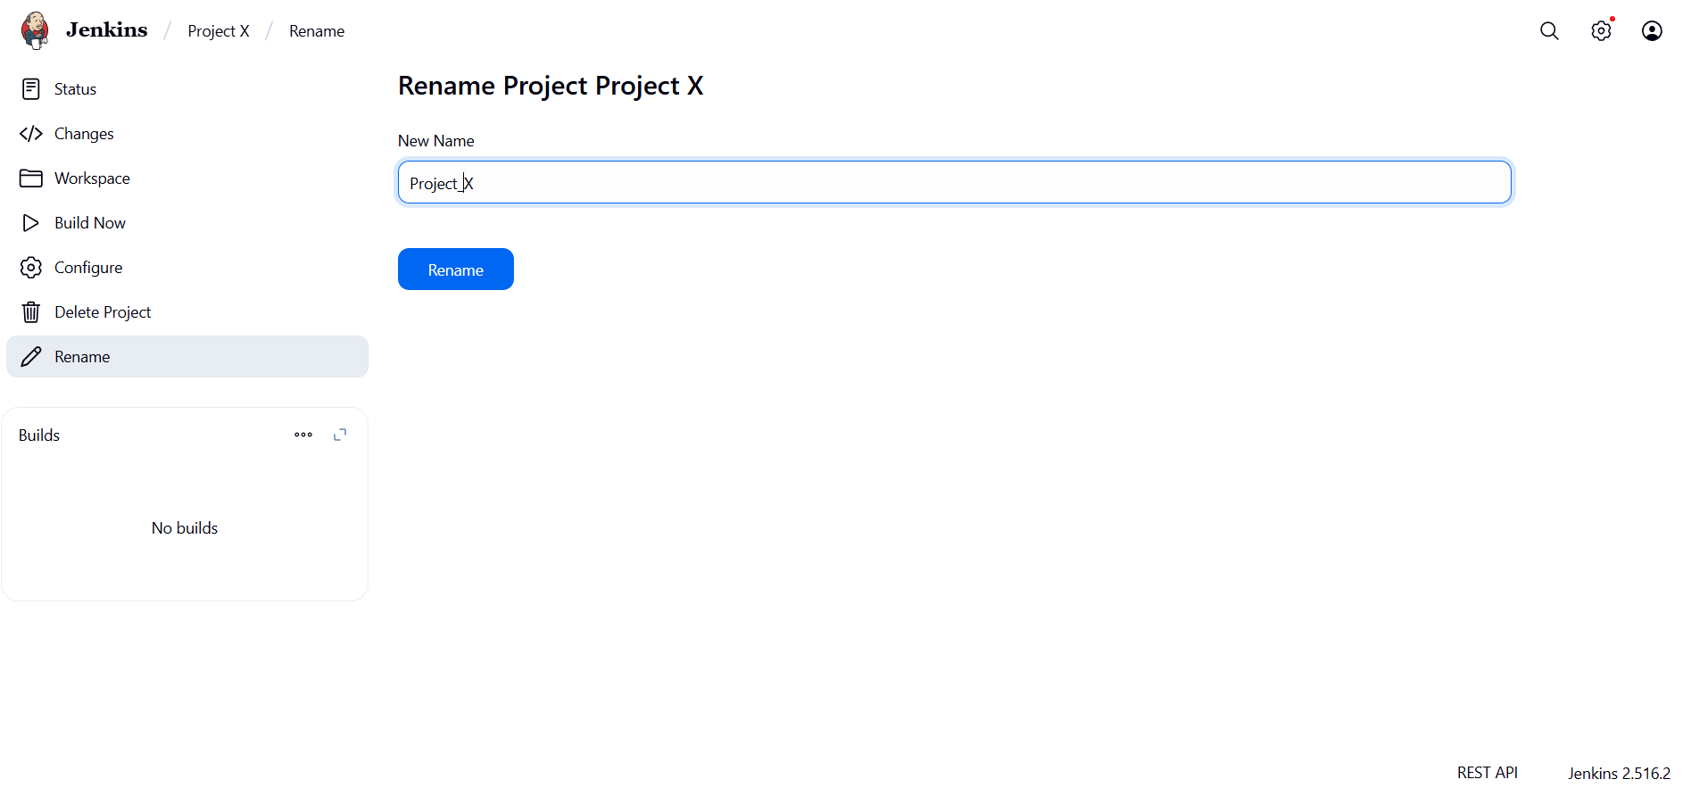

1. Click on the renamed project and then click on **Delete Project** to delete the project

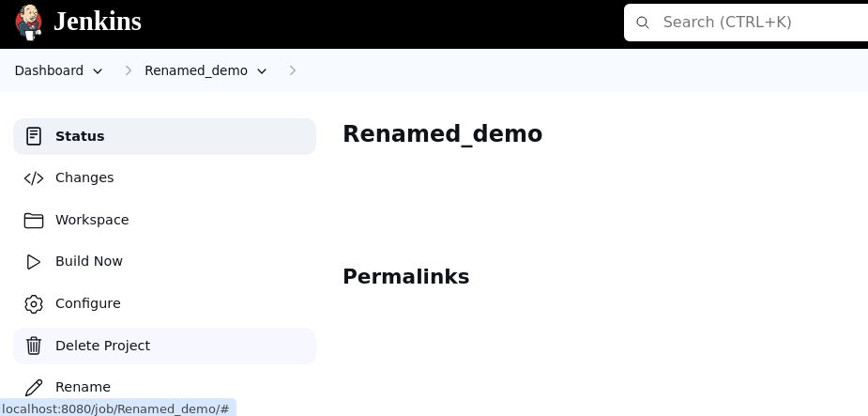

Output:

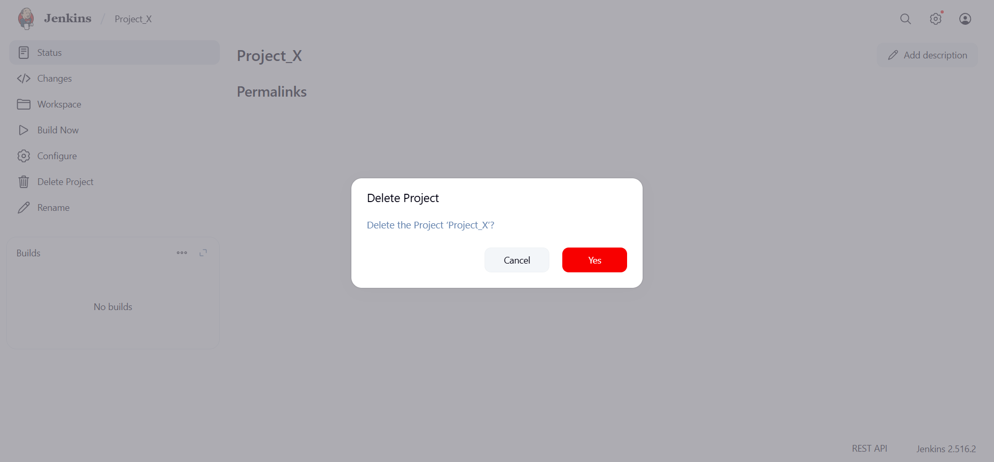

By following these steps, you have successfully managed Jenkins jobs by creating, renaming, and deleting Freestyle Job, streamlining your project workflows within the Jenkins environment.